Digital Health Business Case

Organisation:
[Organisation Name]

Prepared by
[First name Surname]

Date
[23rd Nov 2020]

Exec Summary

There is significant potential for Digital Health to enhance the efficiency and timely delivery of healthcare. This is especially true as [org] serves an ageing population, with health challenges including XXX, XXX and XXX. [To be taken from background section – Delete this]

The NHS long-term plan describes how digitally-enabled care will go mainstream across the NHS. Digital enables care that is patient-centred - personalised, convenient, engaging and available 24/7. Its ability to help people manage their health and engage with services remotely is especially important during COVID-19.

Our organisation has also identified that Digital offers significant potential to meet its strategic priorities.

But for the safe and effective adoption, [org] must overcome awareness, accessibility, trust, governance and commissioning challenges across all of its stakeholder groups, including the community, patients and professionals:

- Awareness – although 93% of health professionals believe health apps can improve a patient’s health, the majority haven’t been trained in this field or use as part of routine practice. Patients are also unaware of health apps, particularly those with long term conditions.
- Accessibility – with 375,000 health apps, neither professionals or patients have the means to find the most effective apps.
- Trust – 85% of health apps do not meet quality thresholds, therefore it is imperative only safe and effective apps are recommended by professionals and used by patients.
- Governance - The lack of clarity around the regulatory landscape and appropriate governance foundations brings ongoing risk that needs management processes to be safeguarded against.
- Procurement – As Digital Health is a new product area, a clear and appropriate commissioning system for purchasing digital health is required.

To achieve our Digital Health ambitions, and unlock the benefits Digital Health offers, [org] recommends working with ORCHA to quickly and efficiently deliver a Digital Health programme. This includes a bespoke app library, filled with apps tested by ORCHA and selected by our clinicians, to embed them into prioritised patient pathways, and a means to prescribe and measure their use.

Part of the NHS Innovation Accelerator Programme, ORCHA works with NHS organisations in 50% of regions, and has a track record of delivering a tailored Digital Health programme to meet our organisation's needs.
If we start this programme during Q4, [org] will have in place the tools and trained workforce, digitally-ready by XXX. [Based on schedule section – Delete this] We anticipate an ROI for this programme of XXX. . [Based on ROI section – Delete this]

Best regards,

[signature]

[name]
Situation

[org] serves a population of approximately XX [From your annual report – Delete this] million and is committed to drive transformation at place-level to improve care for XXX patients.

Digital Health is currently used within the organisation on an ad hoc basis. However, there are a number of clear needs to systematise this now, filling the gaps, and introduce Digital Health in a safe and effective way:

National policy requirements:
- The long term plan chapter 5 outlines how NHS organisations need to link with work to develop and test apps and digital technologies to support self-care and self-management pathways, including artificial intelligence (AI), ensuring the health inequalities gap is not increased as a consequence.

Organisation priorities:
- Digital Health will help deliver against a number of 2020 key priorities for the organisation, including:
- Supporting people to take responsibility for their own health and care.
- developing general practice at scale.
- delivering improvements in mental health.
[Edit to reflect relevant organisation’s priorities – Delete this]

Digital Health is proven to improve key measures, including:
- A&E Wait Times, currently standing at X.
- Key QOF figures, including XX. [To include your key relevant QOF measures – Delete this]

Patient safety and engagement needs:
- Its estimated XXX,000 [50% of the population – Delete this] of residents have downloaded an app to improve their health. This is significant for XXX as:
  - With 85% of apps below quality thresholds, a high proportion of apps will not be effective or could put a patient at harm.
  - If NHS services were engaged with the app selected, it could ensure those with clinical evidence are selected and help improve care. E.g.:
    - WaitLess – reduces A&E wait times by 11%.
    - Brain in Hand – reduces demand on Support Services for those with common mental health conditions by £4,500 each year. Etc. [You can find additional impact figures for apps at the ORCHA website: www.orchahealth.com/impact – Delete this]

- The organisation distributes XXX [Your communications team may have an estimate for this – Delete this] leaflets every year. To be effective these must be ‘read, understood, believed, and remembered.’ Typically, only 24.3% of materials understood by the population(1) and it is unclear how soon they are lost. Digital Health offers the ability to share information in a range of methods and languages; and on a phone, they stay with a patient.
- Often free, they offer the ability for the organisation to save £XX XXX [Your communications team may have an estimate for this – Delete this] spent on leaflets each year.

Source: (1) https://bjgp.org/content/65/632/e192

Target areas, goals and outcomes

[org] has key health priority areas:

- Health statistic 1
- Health statistic 2
- Health statistic 3
[Take from your strategic plan, or government statistics
https://fingertips.phe.org.uk/

https://healthierlives.phe.org.uk/topic/public-health-dashboard#par/cat-113-9/sim/cat-113-9/are/E06000049/ati/202 – Delete this]

The goals of the programme are to:

- Engage key target populations with beneficial Digital Health solutions.

There are a number of suitable condition pathways to focus on, including:
- Pathway 1 – description
- Pathway 2 – description [We would be happy to work with you on identifying priority pathways.– Delete this]

e.g.:
- Outpatients - digital technology to support this encompassing; patient activated follow-ups, remote consultations and self-care.
- Primary Care - working within the personalised care model which includes digital aspects of supported self-care and there is a dependency with the population health management approach for digital interventions.
- Local Council - Assistive technologies and promoting independence.
- Universities – students, staff, alumni & families.

As part of the programme, we will review the readiness of the pathway and teams to build a schedule plan across these areas.

- Link to the wider Electronic Personal Healthcare Record initiative. We will integrate the Identified Digital Health solutions to the local EPHR.

The anticipated outcomes are:

Outcome | Less likely to enter care | Improved health/wellbeing | Better insight into TEC deployment success | Improved demand management | More personalised support | Reduced waiting time for help
Children
Adults
Over 65s

Recommended Solution
[org] recommends that we build a system that overcomes all awareness, accessibility, trust, governance and commissioning challenges, and meets our objectives. This includes:
- Review platform – Use the ORCHA review platform, to ensure aassessment of each Digital Health Solutions compliance with key standards, regulations and best practice. This includes 300+ point assessment covering Data, Security, Clinical/Professional Assurance and User Experience.
- Distribution to Populations – Build a bespoke Digital Health Library for our clinicians and patients. This should contain a comprehensive set of health apps that meet our health priorities.
- Activation Via Health Care Professionals - Work with Clinicians and Clinical Teams. Their engagement in this process is hugely effective with over 60% of recipients of a Pro Recommendation responding positively.
- Integrate into Clinical Pathways - Embedding solutions into Care, to ensure maximum benefit.
- Economic sustainability via procurement – where app purchase is required, build or utilise an existing purchasing platform. For example, London PP partnered with ORCHA in September 2019 to create the first Dynamic Purchasing system which brought together procurement regulations and quality reviews of digital health solutions which could be procured with confidence.
After assessing the market, [org] recommends to partner with ORCHA to deliver this system, as ORCHA has a proven app review and library platform, already used by NHS organisations in 50% of regions, including NHS Digital. The ORCHA system, already built, provides delivery assurance, but also the following benefits:
Rigorous, rapid reviews:
- Intelligent evaluation platform designed with clinicians and IT experts, that assesses 300+ criteria, including NICE technology standards.
- Each evaluation is responsive, personalised to the app. It looks for compliance across 3 areas: data privacy, clinical effectiveness and user experience.
- Automatic re-reviews of app updates and criteria reviewed with experts every quarter.
- It reviews hundreds of health apps every week, across more than 180 condition and category areas. It has reviewed 6,000 apps to date, that we will have access to.
- We can add our own additional assessment criteria, and we can set the system to ensure our preferred apps are marked and appear at the top of search results in the library.
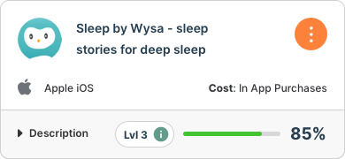
Example score card available for every review:
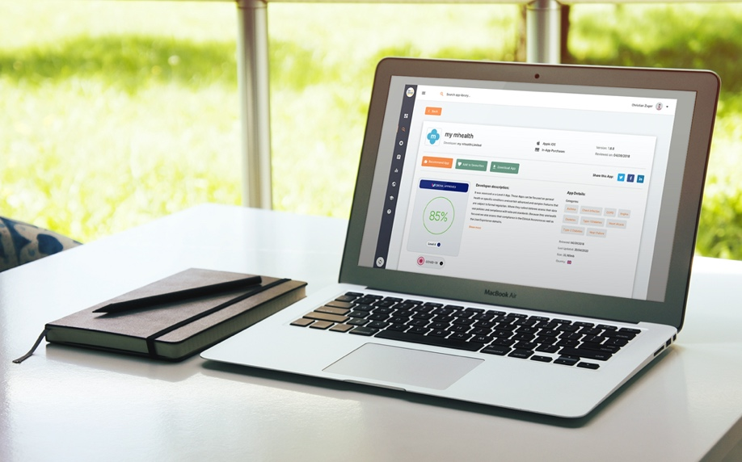

Easy to use app formulary:
- App Library website design or API feed.
- Includes bespoke filters, to enable patients to go straight to their area of care.
- Branded and tailored to our needs.
- Liaise with patients to develop the right library and featured apps.

Example library used by Salford Royal NHS Trust:

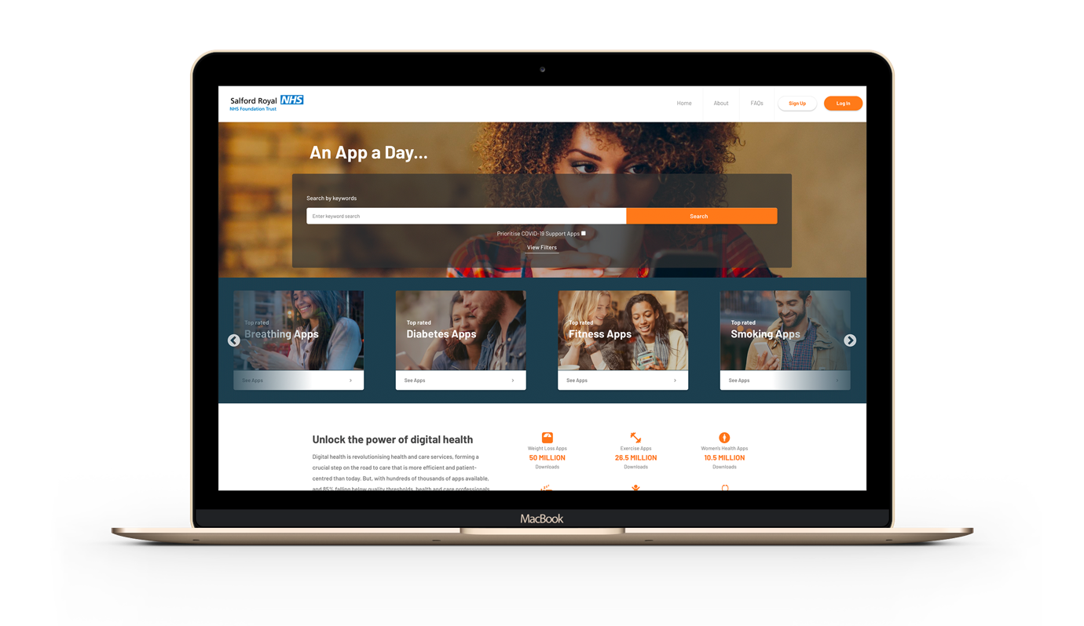

Health and care professional recommendation accounts:
- Built In feature for website that enables staff to recommend apps accurately via email or text.
- Enable staff to maintain favourite apps and view patient downloads.
- Enable cohorts to all be ‘pushed’ a suitable app.
- One of the major drivers of digital activation is health and care professionals. Their engagement in this process is hugely effective with over 60% of recipients of a Pro Recommendation responding positively.

An ORCHA Pro Account dashboard:

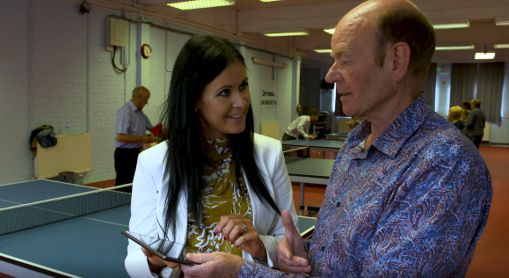
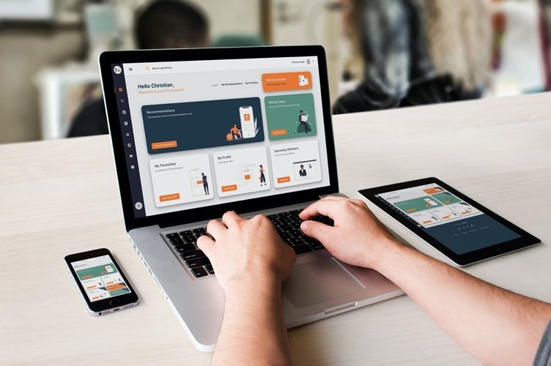
Management analytic dashboard:
- Prescribing activity - who and what Is being recommended.
- Download data - who and what Is being downloaded.
- Search insights - showing what the population is looking for help with.

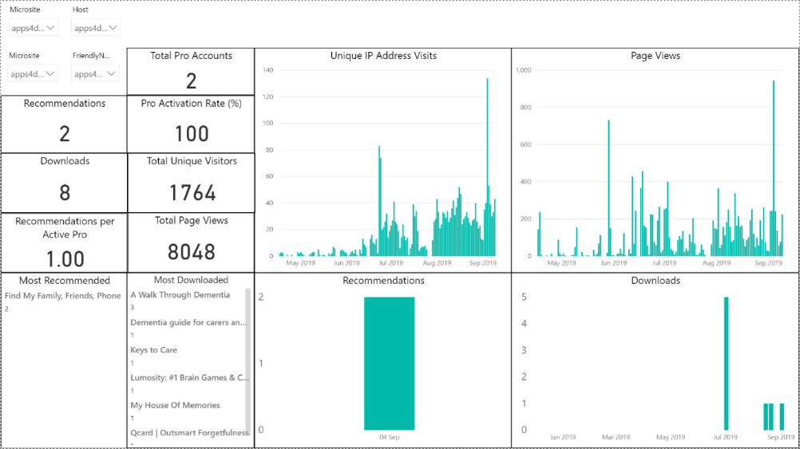
Example analytics dashboard:

Methodology and timeline

In-order to engage professionals and introduce Digital Health most effectively to the organisation, it is recommended that we adopt a series of micro implementations, whereby Digital Health is rolled-out gradually across five specified areas of care.

After a strategic needs assessment, where ORCHA will work with us to identify specific priority conditions, cohorts, pathways, care settings or geographies, each micro implementation includes:

- Identification of the potential service improvements that digital can drive
- Identify the potential ROI and associated key performance indicators
- Select relevant digital health products and solutions that can best deliver the target benefits
- ORCHA conducts an evaluation of any app that hasn’t yet been reviewed.
- Consider if a NHS Digital DAQ assessment layer should be added
- A combination of local clinical / professional assessment and local patient or service user 'testing’.
- Build app library / api, and upload agreed apps.
- Agree a communications strategy to reach the relevant professionals and public.

ORCHA provides a team of experts, led by an experienced implementation manager. The team includes a lead reviewer, who will be our go-to resource for all aspects of the micro-assessment and will liaise with any app developers.

The timeline for implementation is given below. Each area of health undergoing a roll-out, or micro accreditation, takes 12 weeks from start to finish.

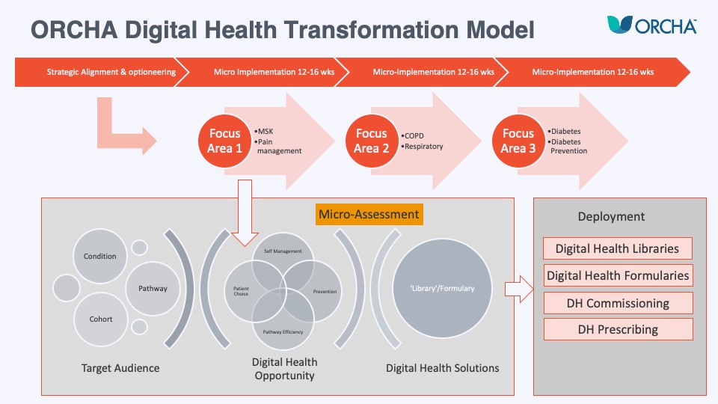

Costs, Benefits, ROI and risks

Costs
The ORCHA offering costs XXX [Take from proposal.– Delete this] per annum. This includes:

Set-up:
Project implementation change management across 5 priority areas.
App assessments for relevant apps.
Bespoke app library build.

Annual fees:
App library access for residents.
Professional account licence for X staff members.

Benefits
Expected benefits for the programme are outlined below.

Value  Component | How does the project demonstrate value in this area? | How will this be measured?  (metrics) | What is the current  baseline? | What is the  target? | When will this  be delivered?
Improvements to Care Outcomes  (A) | 1) Providing a library with digital interventions for education and awareness to support self-management that has been evaluated and reviewed.  2) Measures the increase in Digital culture, impact /adoption collectively across pathways.  3) Provides a wide-range of support for patients to self-manage in a digital format that is easy and accessible, which will support improved care outcomes across a number of specialities. | 1) Public analytics/BI use of the platform, search words, most downloads, times of search.  2) Through the platform analytics as shown in Appendix A.  3) As above. | 1) Unknown.  2) This is not currently measured. | 1) As we don’t have any insights into usage of digital health, ORCHA analytics data will help us to build a picture of the digital health usage in Enter Your Org name...  2) Full usage from those provided prescribing logins in regular  digital prescriptions  involving self-management. | Enter Date here…  Enter Date here…
Improvements to Quality & Safety of services  (B) | 1) Provides a library of evaluated digital health interventions that assure prescribers / clinicians confidence because there is a process of evaluation and continuous review taking place.  2) Confidence for those delivering services that patients are accessing information that is reliable, accurate and supported by a robust evaluation process. | 1) Prequestionnaire to prescribers. | 1) unknown.
Improvement to Patient Staff Experience  (C) | 1) Cross Reference A1.  2) Cross Reference B1.  3) Simplified navigation of fragmented information in multiple websites that are not always fully up to date for the person. (Our Enter Your Org name... to be the landing page to bring the digital library and websites together).  4) Workforce are not always sure what is available in digital self-management or what can be endorsed / recommended. This raises awareness and provides structure and permission to start discussing digital health and online – self management.  5) Public is more likely to download and use a health app that has been recommended / suggested by a healthcare professional as opposed to searching app stores for one that may be ‘ok’.  6) Provides support in relation to self-care and management for patients in another format – one which is easy, accessible and ‘expected’ by most.
Improvements in Capacity and Efficiency  (D) | 1) Efficiency – Reduction in unnecessary website development costs.  2) Within outpatient services, there are opportunities to maximise the use of digital technology, particularly in relation to self-care / self-management – this may mean utilising apps to improve capacity and efficiency e.g. supporting patient initiated follow-ups.
Improved access to services  (E) | Within outpatient services, there are opportunities to maximise the use of digital technology. Providing a library of health apps may enable service to be delivered differently and support improved access to services for those that really need to see a clinician – e.g. remote monitoring, patient-initiated follow-up.

ROI

ORCHA is able to provide ROI estimates based on health economic clinical evidence in certain health areas.

An illustration: If an ORCHA app library to serve 27 GP practices, enabled 20% of its COPD patients to engage with Digital Health tools from the library, a £78,854 reduction in healthcare costs can be expected, delivering an annual return of £13 per £1 invested.

Note: The Investment in ORCHA has been split equally between each locality and represents approximately one fifth of the overall costs on the basis that there will be 5 micro-implementation cycles.

Risks
The risks associated with this programme include:

Description | Risk Score | Current Mitigation | Risk Owner
Lack of uptake / prescribing of the health app – | 4 | Ongoing comms & engagement with other programmes of work, clinicians etc Acknowledge that this is a culture change and new way of working.
Patients do not use the library and health apps | 4 | Comms & Engagement Plan.

Risk Score = consequence (1-5)x Likelihood (1-5)

Low Risk  Red 0 - 3 | Moderate Risk  Red 4 - 6 | Significant Risk  Red 8 - 12 | High Risk  Red 15 - 25

Governance

The project will be managed with a dedicated project team and will include representation from each of the respective areas work.

Each of the senior users will identify the specialities and representation to form a sub group and work with the senior supplier in requirements and training prior to deployment. Each sub group will work with the project team in the Evaluation criteria.

The diagram below depicts a RACI stakeholder model, the smallest oval showing those Responsible for the Programme, and moving outwards those Accountable for it, those needing to be Consulted and those needing to be Informed during the lifetime of the project. This model is not static and can be amended at any stage to reflect any stakeholder changes:
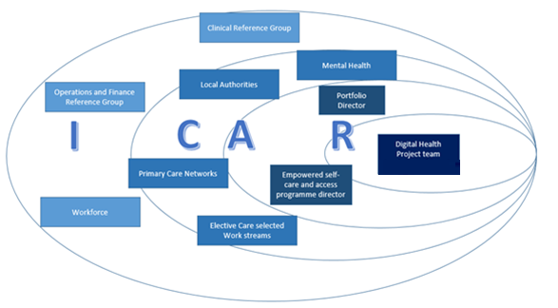

About ORCHA
The Organisation for the Review of Care and Health Apps (ORCHA) is the world’s leading, independent digital health evaluation and distribution organisation. We help health and care organisations to deliver the right digital health apps, to the right people, at the right time. Its unique insight, assessment, and implementation services are improving the health of the population, the health of our health systems and the health of the health app ecosystem.
ORCHA conducts reviews for government organisations across Europe, the Middle East, and Australasia.
In the UK, ORCHA conducts reviews for NHS Digital and NHS providers in 50% of regions. NHS England is accelerating adoption across the NHS, placing ORCHA in its National Innovation Accelerator Programme.
Clients in the UK include: Manchester Mental Health, NW London, Salford Royal NHS Foundation Trust, Society of Physios, British Dietetics Association, British Lung Foundation etc.
Examples of programmes conducted by ORCHA can be found:
- Northern Ireland Government implements library as part of its COVID-19 response: https://www.youtube.com/watch?v=5unQ9bWz2hk
- The Chartered Society of Physiotherapy introduce specialised app library to enable their 50,000 members to find and recommend apps to patients: https://www.youtube.com/watch?v=GuwzwvON82k
- HSCNI build an app library with and for people living with dementia: https://www.youtube.com/watch?v=G0xRgtN0klg
- A partnership of 27 NHS organisations across Cheshire and Merseyside, has introduced an app library so that women can access safe apps with confidence through pregnancy: https://www.youtube.com/watch?v=A2s2p2mm9Mk&t=11s
- Papyrus, the national charity for the prevention of young suicide, worked with ORCHA to embed health apps into its HOPELINE suicide prevention helpline:
- https://www.youtube.com/watch?v=hVXcY6G7KmQ&t=102s

- The Health and Social Care Network for Mental Health for the whole of Northern Ireland - https://www.orcha.co.uk/news/northern-ireland-health-minister-announces-new-health-app-library-launch/
- Chartered Society of Physiotherapists - https://mailchi.mp/3fc8e9677ec6/best-apps-for-remote-physiotherapy
- Improving Me - https://www.youtube.com/watch?v=A2s2p2mm9Mk&t=1s
- HSCNI - https://www.youtube.com/watch?v=s-i3Kwl1Zvg&t=111s
- Fitmums - https://www.youtube.com/watch?v=gTU2_c6tFg0&t=1s
- Bolton - https://www.youtube.com/watch?v=vIzly3dqtdM&t=10s
- Bolton 2 - https://www.youtube.com/watch?v=t5Oi1cQqPM8&t=1s
- Salford - https://www.youtube.com/watch?v=zoE-p74VC3E
- Salford 2 - https://www.youtube.com/watch?v=Y-TfiZArty8
- Salford 3 - https://www.youtube.com/watch?v=EAZp6QcRd5A
- LMA - https://www.youtube.com/watch?v=fudzR4-kZhk&t=1s
- Transforming Systems - https://www.youtube.com/watch?v=vz2ub9UFkbo&t=2s
- Bradford - https://www.youtube.com/watch?v=hr6s2pfKfjY&t=11s
- Bradford 2 - https://www.youtube.com/watch?v=YWKU338zGQY&t=48s
- Witton Park Academy (DHS) - https://www.youtube.com/watch?v=4nQ1Cr8BGv4&t=8s
- Wingate Medical Centre - https://www.youtube.com/watch?v=8VcuUAmbWt4
- LCFT - https://www.youtube.com/watch?v=Vf24LFIZ4s8&t=6s

